Exercise 1: Setting Up JUnit:

Calculator.java:

public class Calculator {
public int add(int a, int b) {
return a + b;
}
}

CalculatorTest.java:

import org.junit.Test;
import static org.junit.Assert.assertEquals;
public class CalculatorTest {
@Test
public void testAdd() {
Calculator calculator = new Calculator();
int result = calculator.add(5,4);
assertEquals(9, result);
}
}

Output:
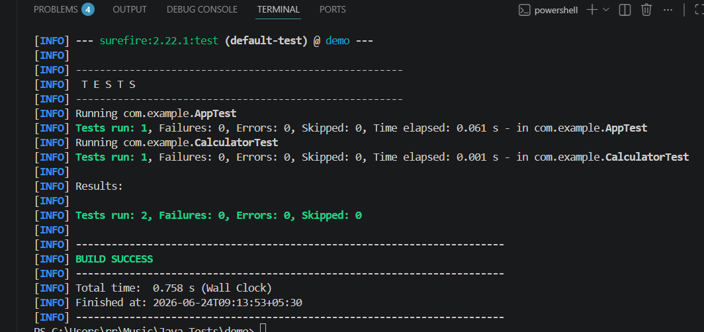

Exercise 2: Writing Basic JUnit Tests:

MathUtils.java:

public class MathUtils {
public int add(int a, int b) {
return a + b;
}
public int multiply(int a, int b) {
return a * b;
}
public boolean isEven(int number) {
return number % 2 == 0;
}
}

MathUtilsTest.java:

import org.junit.Test;
import static org.junit.Assert.*;
public class MathUtilsTest {
@Test
public void testAdd() {
MathUtils mathUtils = new MathUtils();
int result = mathUtils.add(5, 4);
assertEquals(9, result);
}
@Test
public void testMultiply() {
MathUtils mathUtils = new MathUtils();
int result = mathUtils.multiply(2, 8);
assertEquals(16, result);
}
@Test
public void testIsEven() {
MathUtils mathUtils = new MathUtils();
assertTrue(mathUtils.isEven(20));
assertFalse(mathUtils.isEven(31));
}
}

Output:
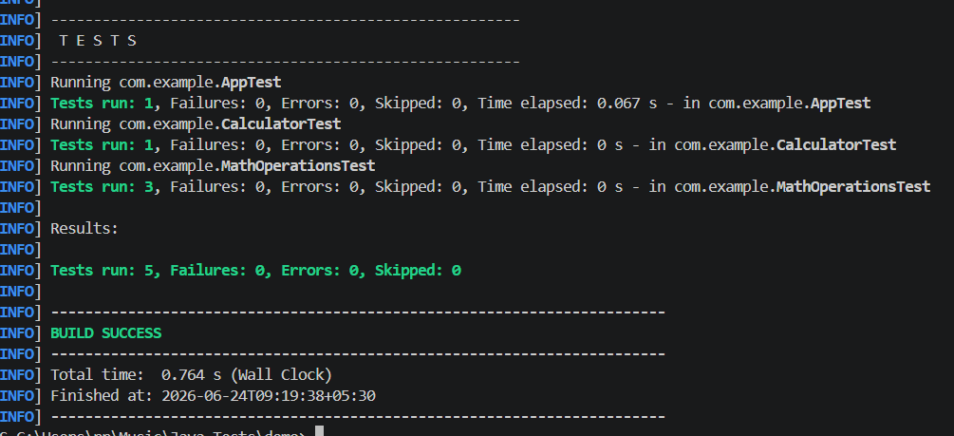

Exercise 3: Assertions in JUnit:

AssertionsTest.java:

import org.junit.Test;
import static org.junit.Assert.*;
public class AssertionsTest {
@Test
public void testAssertions() {
assertEquals(3, 1 + 2);
assertTrue(7 > 1);
assertFalse(7 < 1);
Object obj1 = null;
assertNull(obj1);
Object obj2 = new Object();
assertNotNull(obj2);
}}

Output:
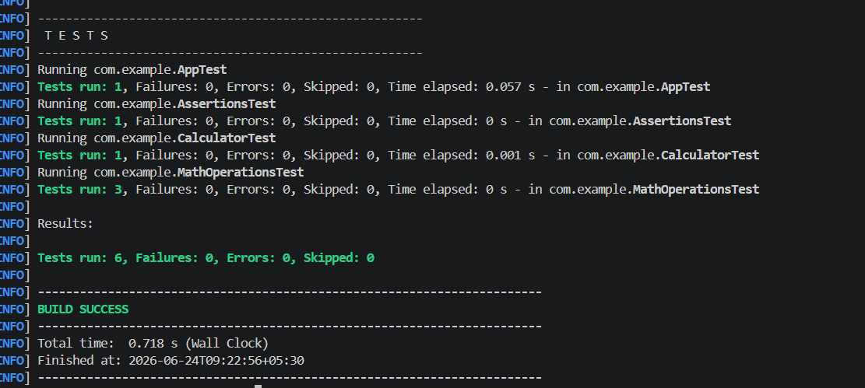

Exercise 4: Arrange-Act-Assert (AAA) Pattern, Test Fixtures, Setup and Teardown Methods in JUnit:

Calculator.java:

public class Calculator {
public int add(int a, int b) {
return a + b;
}
public int subtract(int a, int b) {
return a - b;
}
}

AAATest.java:

import org.junit.Before;
import org.junit.After;
import org.junit.Test;
import static org.junit.Assert.*;
public class AAATest{
private Calculator calculator;
@Before
public void setUp() {
System.out.println("Setting up...");
calculator = new Calculator();
}
@After
public void tearDown() {
System.out.println("Tearing down...");
calculator = null;
}
@Test
public void testAdd() {
int a = 5;
int b = 3;
int result = calculator.add(a, b);
assertEquals(8, result);
}
@Test
public void testSubtract() {
int a = 10;
int b = 4;
int result = calculator.subtract(a, b);
assertEquals(6, result);
}
}

Output:
